Admin :  
steps

Make a new folder in the palate folder named admin

Npm create vite@latest .

React

Javascript

Npm install

Npm run dev

Packages installed :  
axios

React-toastify (for in website notification)

React-router-dom

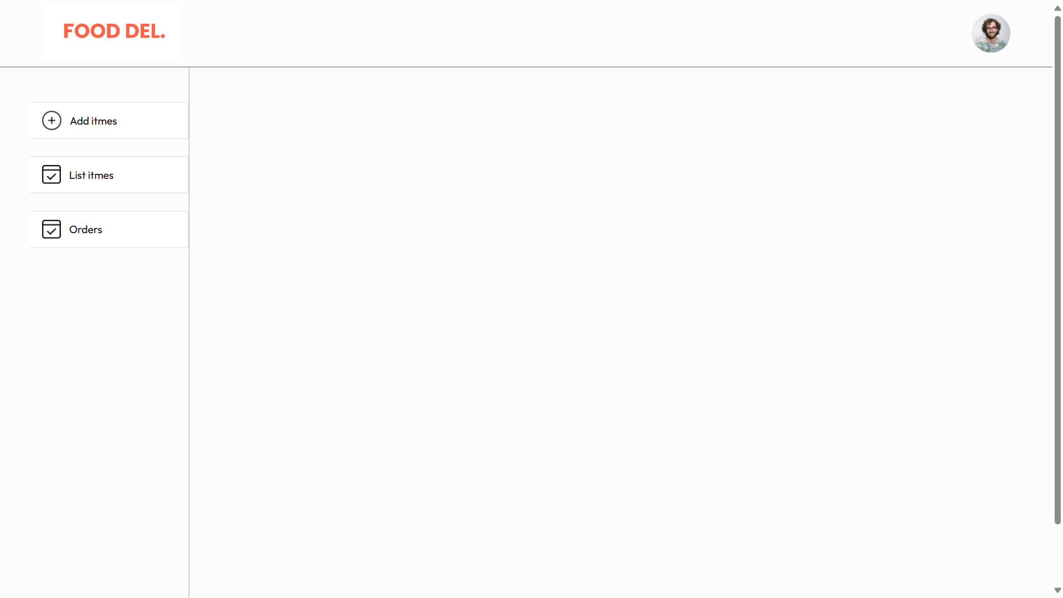

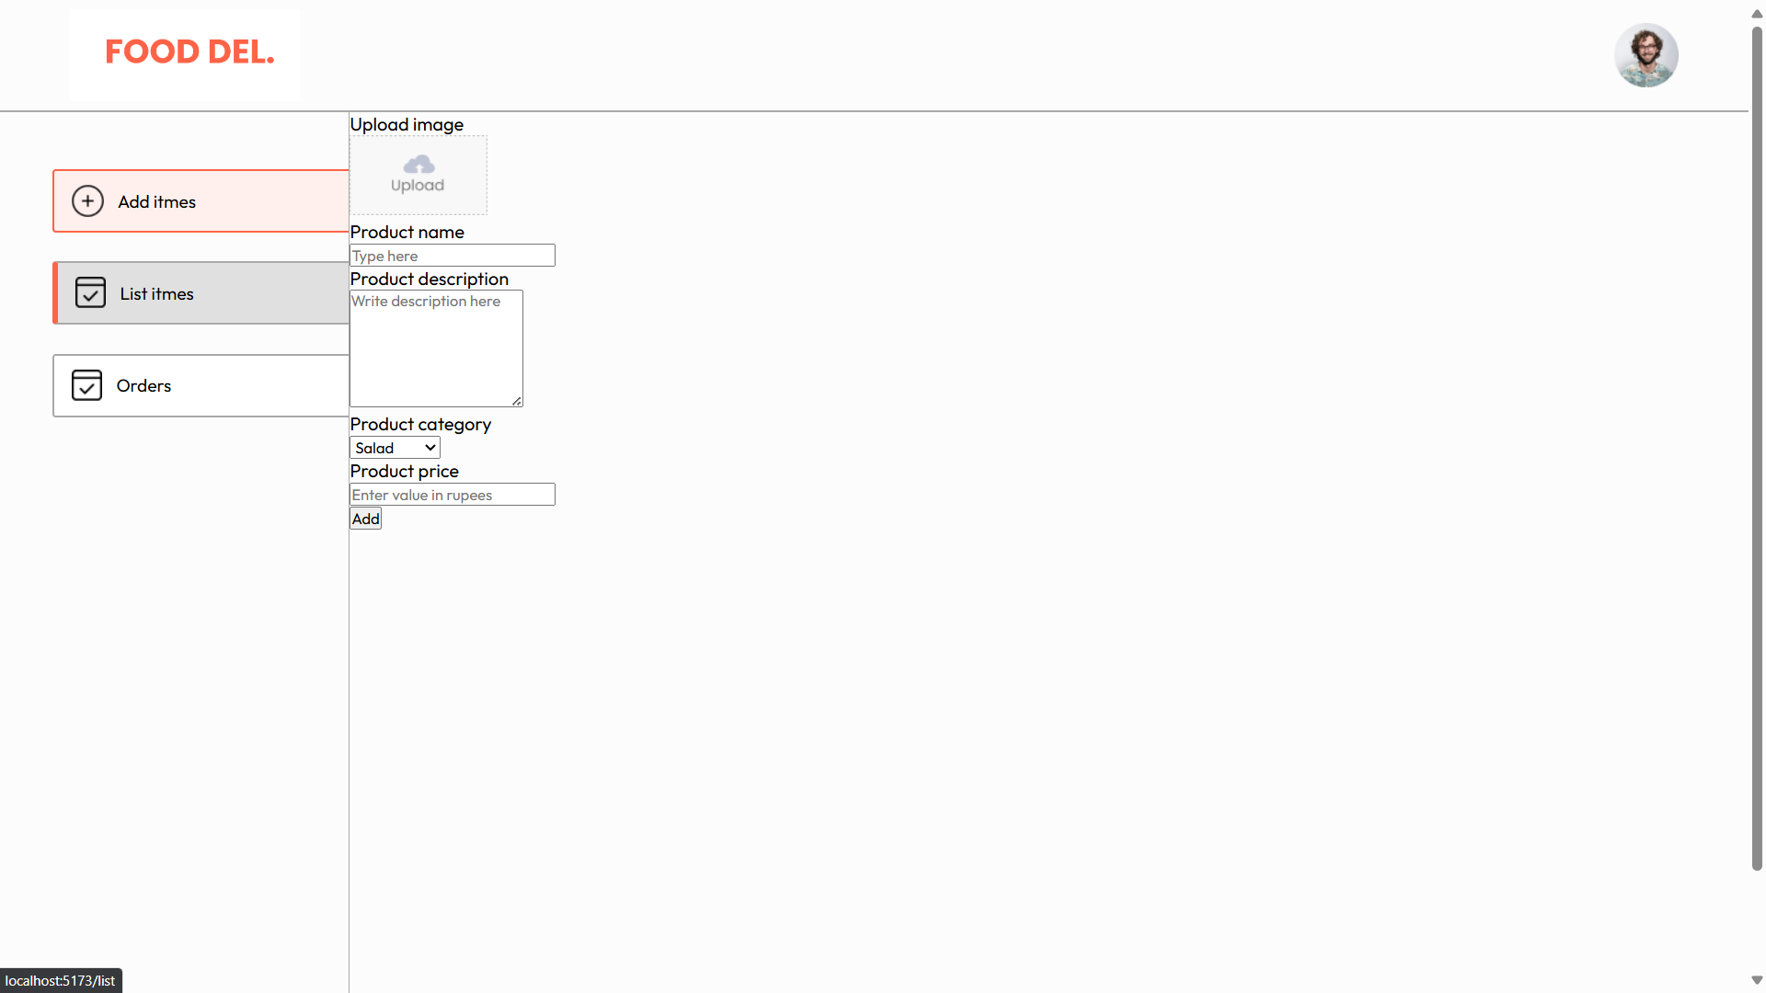

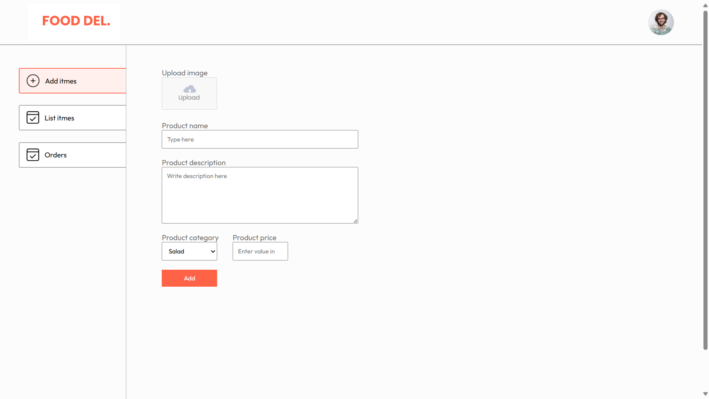

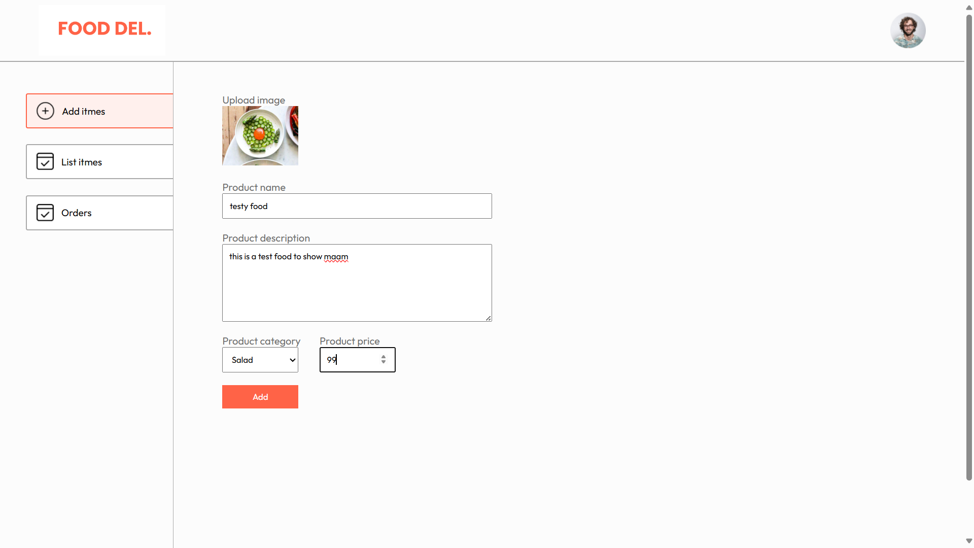

Toastify notification:

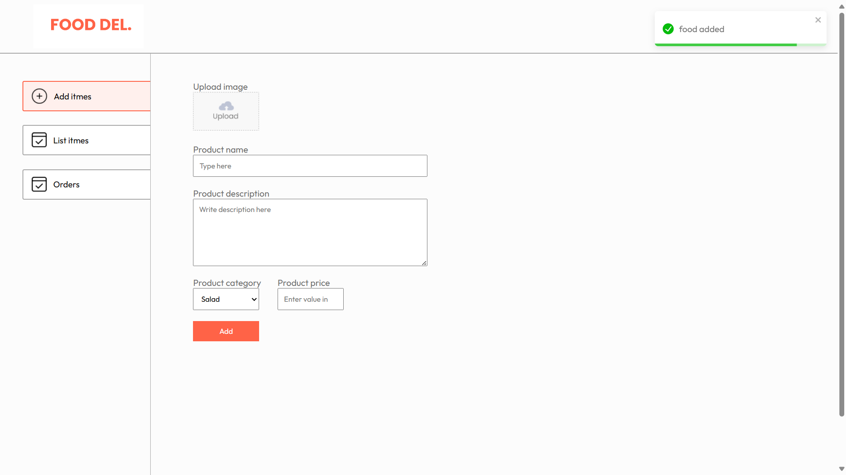

Food removed:

